Healthcare Claims Analytics — End-to-End Hybrid BI Project

Problem Statement
Healthcare organizations generate large volumes of claim data across multiple systems such as provider databases, cloud storage, and analytics platforms. These datasets are often distributed, inconsistent, and difficult to visualize effectively. Traditional reporting workflows struggle with:
- Multi-source data integration
- Lack of interactive analytics
- Inconsistent data cleaning practices
- Static dashboards without contextual intelligence
The challenge was to design a realistic end-to-end healthcare analytics pipeline that integrates multiple cloud platforms and produces an interactive business intelligence dashboard.

Project Objectives
The main objectives of this project were:
- Generate realistic healthcare claim datasets using synthetic data engineering.
- Simulate enterprise architecture by distributing data across Databricks and AWS S3.
- Build a scalable star schema model for analytical reporting.
- Develop a fully interactive Power BI dashboard.
- Implement advanced features such as:
  - Dynamic titles
  - Conditional KPI formatting
  - Tooltip report pages
  - Cross-visual filtering
- Demonstrate full-stack data analytics skills from data engineering to visualization.

How This Project Helps
This project demonstrates how modern healthcare analytics systems operate in real environments.
It showcases:
- Hybrid cloud data ingestion
- Data cleaning workflows
- Analytical modeling
- Interactive dashboard design
The solution bridges the gap between raw data engineering and business intelligence storytelling.

Technology Stack Used

Data Engineering Layer
- Python (pandas, numpy)
- Databricks Lakehouse
- Delta tables

Cloud Storage
- Amazon AWS S3
- Presigned URL access

Analytics & Visualization
- Power BI Desktop
- Power BI Data Modeling
- DAX (Data Analysis Expressions)

Development Environment
- Databricks Notebook (IPython)
- macOS + Windows via Parallels

Why This Tech Stack Was Chosen

Databricks
Used for generating and structuring large synthetic datasets efficiently. Provides scalable data engineering capabilities.

AWS S3
Simulates real-world distributed storage architecture where datasets exist across multiple cloud environments.

Power BI
Chosen for:
- Advanced DAX calculations
- Enterprise-level interactive visuals
- Strong integration with Databricks
This combination mirrors real enterprise healthcare data pipelines.

Project Scope
The project focuses on:
- Batch data ingestion
- Multi-source data modeling
- Interactive dashboard development

Architecture Diagram
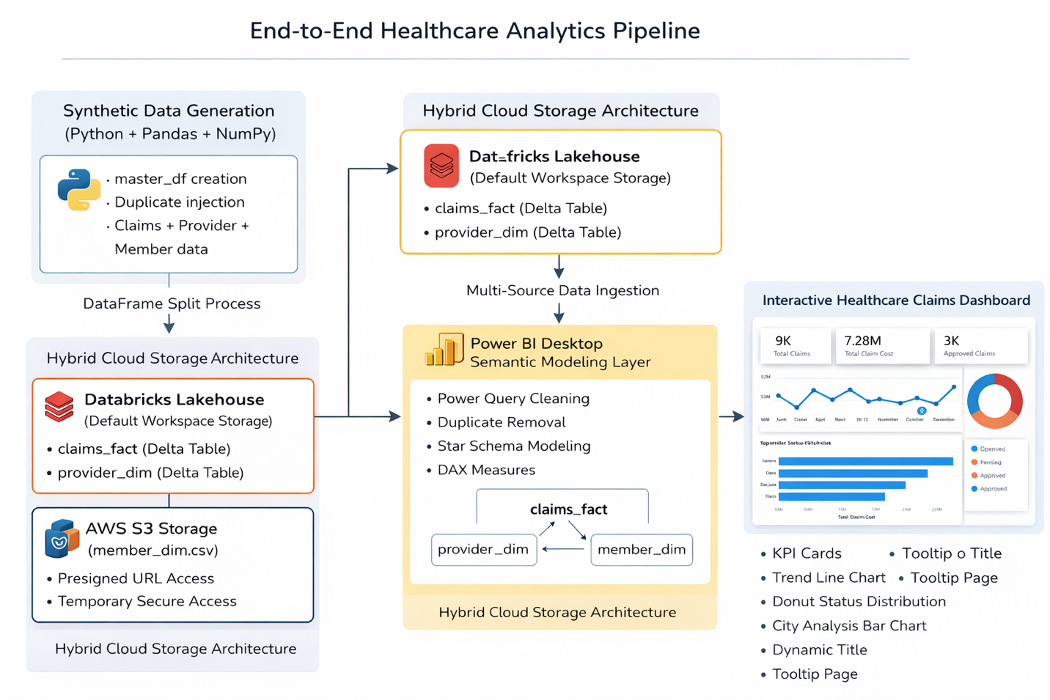

Project Flow Diagram
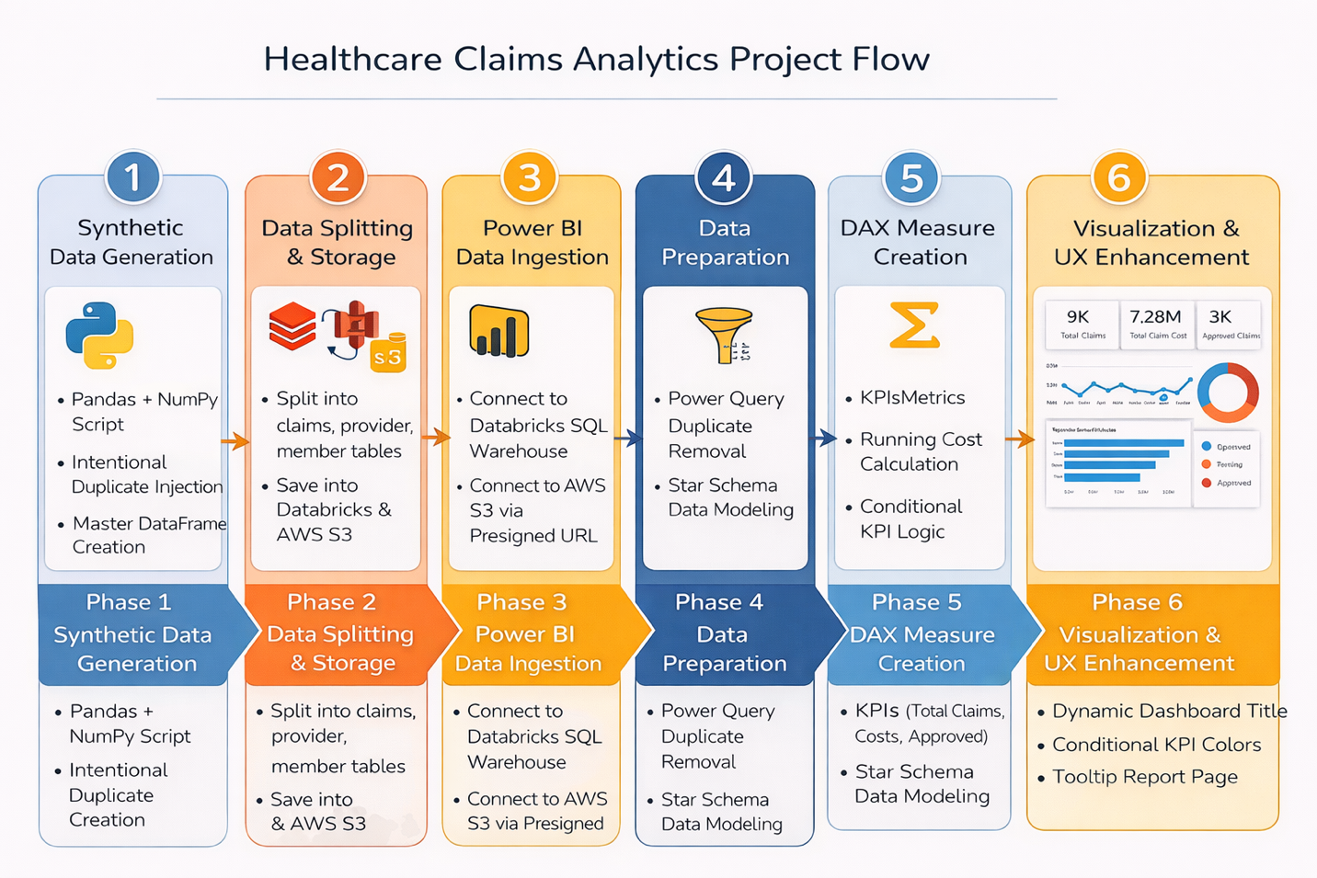

Methodology
The project follows a layered BI architecture:
- Synthetic Data Engineering
- Data Distribution across cloud platforms
- Power BI Data Modeling
- Interactive Visualization Development
The methodology emphasizes separation between data preparation and presentation layers.

Detailed Implementation

Phase 1 — Synthetic Data Generation
A master healthcare dataset was created using Python:
- pandas
- numpy
Data included:
- Claim transactions
- Provider attributes
- Member information
Duplicates were intentionally inserted to demonstrate data cleaning within Power BI.

Phase 2 — Data Splitting
The master dataframe was split into:
- claims_fact
- provider_dim
- member_dim
This created a realistic star schema foundation.

Phase 3 — Hybrid Storage Architecture

Databricks Storage
Stored:
- claims_fact
- provider_dim
Inside default workspace namespace.

AWS S3 Storage
Uploaded:
- member_dim.csv
Generated presigned URL for secure access from Power BI.

Phase 4 — Power BI Data Ingestion

Databricks Connection
Connected via:
- Server hostname
- SQL warehouse HTTP path

AWS S3 Connection
Loaded data using presigned URL.

Phase 5 — Data Cleaning
Performed inside Power BI:
- Duplicate removal
- Column validation
- Relationship verification

Phase 6 — Star Schema Modeling
Relationships built:
provider_dim → claims_fact ← member_dim
Benefits:
- Efficient filtering
- Simplified DAX logic
- High-performance visuals

Phase 7 — DAX Measures Created
- Total Claims
- Total Claim Cost
- Running Cost
- Approved Claims
- Dynamic Dashboard Title
- KPI Conditional Color

Phase 8 — Dashboard Development
Visuals implemented:
- KPI Cards
- Monthly Spend Trend Line Chart
- Claim Status Donut Chart
- Provider City Bar Chart
- Interactive slicers
Advanced UX features:
- Tooltip report page
- Dynamic header title
- Conditional KPI styling
- Cross-filter behavior

Project Deliverables

Interactive Dashboard
Provides:
- Monthly healthcare spend analysis
- Claim status breakdown
- Provider-based filtering
- Dynamic contextual analytics
Published Power BI link:
https://app.powerbi.com/view?r=eyJrIjoiNDVhMjExNzctYTU5YS00YTk3LWIzNmQtODk0ZTJjODUyOTQ4IiwidCI6IjcwZGUxOTkyLTA3YzYtNDgwZi1hMzE4LWExYWZjYmEwMzk4MyIsImMiOjN9

Challenges Faced
- Databricks DBFS root restrictions
- Cross-platform driver setup
- Presigned URL generation
- Multi-source modeling complexity
- Maintaining consistent visual styling

Scalability
The architecture supports scaling through:
- Larger synthetic datasets
- Distributed Databricks processing
- Incremental refresh in Power BI

Alternative Implementations
- Snowflake instead of Databricks
- Direct IAM-based S3 integration
- Azure Data Lake architecture
- Live DirectQuery models

Future Scope
- Real-time batch automation
- Incremental refresh pipelines
- Machine learning claim prediction
- Deployment via Power BI Service Apps

⭐Additional Skills Demonstrated
- Hybrid cloud integration
- Data engineering workflow design
- Advanced DAX development
- UX-focused dashboard design

